**R-S Flip Flop**

|  |  |  |  |
| --- | --- | --- | --- |
| **Set** | **Reset** | **Q** | **Q’** |
| 1 | 0 | **0** | **1** |
| 1 | 1 | **0** | **0** |
| 0 | 1 | **1** | **0** |
| 1 | 1 | **0** | **0** |

7. Because flip-flop circuit stores one bit at a time in a digital circuit. ( All the digital circuits need to store the data however large or small. )

8. First time setting both inputs to 1, Q was on. Second time setting both pins on, Q’ was the one that’s on.

**D Flip Flop**

|  |  |  |  |
| --- | --- | --- | --- |
| **Clock** | **Pin** | **Q** | **Q’** |
| 0 | 0 | **0** | **1** |
| 0 | 1 | **0** | **1** |
| 1 | 1 | **1** | **0** |
| 1 | 0 | **0** | **1** |

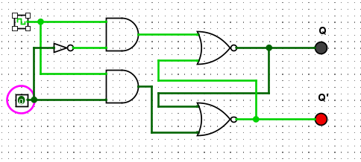

11. The Q follows the stage of the input pin ( if it’s 1, then Q is also 1 and also the other way around ), this is as long as the clock pulses, if it doesn’t it will stay the same until the clock pulses.

12. The role of the clock is to send the signal and turns on the Q output following the Pin’s status ( either on or off ). The change of state of the output is dependent on the rising edge of the clock. The output (Q) is the same as the input and can only change at the rising edge of the clock.

13. Because an unclocked R-S flip-flop has issues. D flip flop is a better alternative that is very popular with digital electronics. They are commonly used for counters and shift registers and input synchronization.

**JK Flip Flops**

|  |  |  |  |
| --- | --- | --- | --- |
| **J** | **K** | **Q (when clocked)** | **Q’(when clocked)** |
| 0 | 0 | **No change** | **No change** |
| 1 | 0 | **1** | **0** |
| 0 | 1 | **0** | **1** |
| 1 | 1 | **Toggle** | **Toggle** |

16. JK flip-flop can be converted into a D-type flip-flop by driving its J and K input pins with the D input and its negation, respectively. This means we’ll have 4 combination outputs.

17. It also can be converted to a T flip-flop just to drive both of its input pins (J and K) with the input T.

|  |  |  |
| --- | --- | --- |
| **Ox** | **Input Binary** | **Output Binary** |
| **0** | 0000 | 0000 |
| **1** | 0001 |  |
| **2** | 0010 |  |
| **3** |  |  |
| **4** |  |  |
| **5** |  |  |
| **A** |  |  |
| **B** |  |  |
| **C** |  |  |
| **D** |  |  |
| **E** |  |  |
| **F** |  |  |